Experiment # 04

**Introduction to Microsoft Power Point**

**Objective**

1. Choosing slide design and color theme for power point slides
2. Writing headings and text in a power point slide.
3. Adding figures, animations, word art and tables in a power point slide.
4. Adding notes with slide as per presenter.
5. Starting and controlling of a slide show.

**Theory**

1. Introduction:

PowerPoint is an application used for the creation of presentations. These presentations are laid out in a "storyboard" type fashion, where individual slides are created and formatted with text and images. PowerPoint presentations are widely used in classrooms as note outlines for teachers and for project presentations by students.

The point of the slides in PowerPoint presentations is NOT to fit as much detailed information as you can onto a single slide. Rather, each slide should contain elements that briefly sum up the major idea(s) of what you will be presenting for the duration of the slide.

The style in which you create slides is completely up to you. PowerPoint allows you to choose from a wide variety of formats that include sections such as titles, lists, images, or charts. Any of these can be incorporated into your presentation. The main thing to keep in mind, however, is that an audience will be viewing this material; it must be large enough to read, yet not so large that it takes up far too much of the screen to include relevant information.

1. Opening Power Point:

To begin running PowerPoint, go to the Start menu, and navigate to "Programs." If you navigate to the Programs menu, and from there, navigate to the Microsoft Office applications, you will see Microsoft Office PowerPoint 2003 listed.



1. About the slides:

On any given slide in a PowerPoint presentation, you can present your information in a variety of ways. You can type in text using text boxes, insert images or sounds, create charts, graphs, or lists, and make text columns. Each separate element in a slide (be it text or an image) is considered its own object, and can be moved and modified independently from other objects in a slide. We will get into the specifics of how to actually create these elements in a bit, but you should know from the start that you are not limited when creating a slideshow.

1. The opening screen:

When you start PowerPoint, a number of screens and panels will appear on your screen. You can go in a number of directions from here.

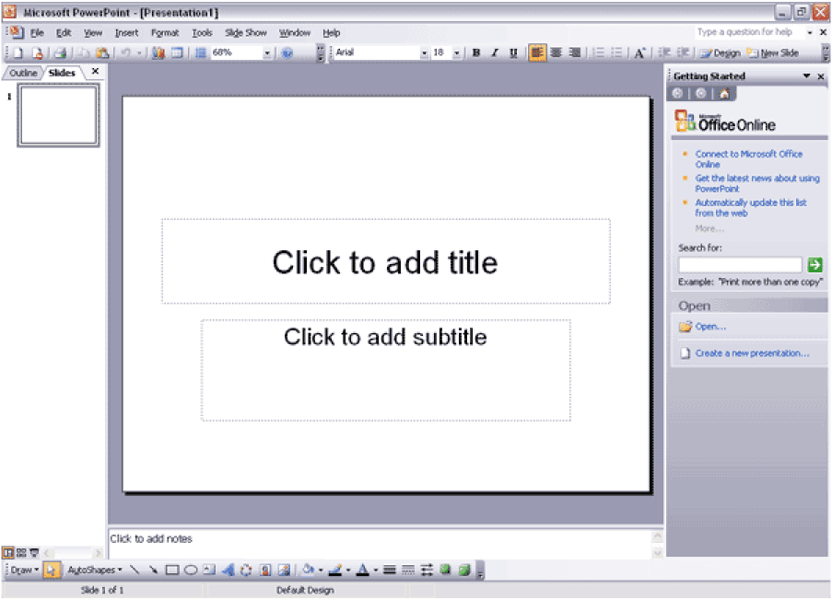

Across the top of the screen, you’ll notice a toolbar that looks similar to ones used in word processing program. These tools allow you to format and edit text and other elements in your slide. We’ll get into more detail about this toolbar later on in the tutorial.

On the left side of the screen, there’s a panel with two tabs called “Slides” and “Outline” this allows you to view all of your slides in your slideshow as small images (in the “Slides” mode) or as text (you can view as text if you click on the “Outline” tab).

The panel on the bottom has more tools for editing your slides, such as Drawing and AutoShapes.

1. The Task Pane:

The panel on the right side of the screen is actually called the “Task Pane.” As the name implies, it controls all the main slide control tasks for your presentation.

If you ever lose sight of this panel, go to the menu bar in PowerPoint, navigate to “View,” select the “Tool bars” menu, and make sure “Task Pane” is selected.



When you first open PowerPoint, the “Task Pane” is set to display as the “Getting Started” panel. This will help you in beginning your presentation.

If you click on the small triangle, you can expand the menu to see all of the sub-menus included in the Task Pane:



You may find the third potion of the menu the most useful. Using these menus, you can format the Slide Layout, Slide Design (make custom color schemes, and animations), Custom Animations, and Slide Transitions.

For now, let’s take a detailed look at the "Getting Started" panel on the right side of the screen.

1. Opening a Power point file:

In the "Open" section on the bottom of the “Getting Started” panel, you have the option to open a pre-existing PowerPoint file (PowerPoint files end in the file extension ".ppt") by clicking on the "Open" icon.

When you click on the "Open" icon, navigate your computer to locate the file you wish to open. Select the file name and click "OK" to open the file. You can edit the presentation as needed.

1. Create a new presentation:

If you want to start a new presentation, you can do one of many things. Click on the "Create a new presentation..." button. You'll notice a change in the "Getting Started" panel. It's now called "New Presentation," and you can also move forward, back, and go "home" using the buttons on the top of the panel if you want to go back and read information you may have passed.



In the "New" section, you can make a new presentation using a blank presentation, a design template, the AutoContent wizard, an existing presentation, or from a photo album. At this point, we’ll describe in detail the different ways you can begin your new presentation.

1. Blank Presentation:

Click on the “blank presentation” button. The panel will then give you a number of slide layouts to choose from.



Please note the different kinds of objects in the slide layouts: long bars of gray represent text boxes, boxes with little pictures in them represent image objects, and the bulleted lists represent unordered lists.

If you choose to select from one of these pre-made slide layouts, keep in mind that you can change the positioning and even delete some of the objects in the layout. Nothing is set in stone, and you can always modify objects, even in the pre-made slide layouts.

If you want to try to be a little more advanced, you can choose to make a completely blank slide, and then insert objects and text as you work (the blank slide is the one at the top of the “Content Layouts” area in the “Slide Layout” panel).

Find a layout you like, and click on it in the panel window. As soon as you click on the layout in the “Slide Layout” panel, the layout will be applied to the current slide.

From this point, you are free to create the rest of your presentation as you see fit. To create a new slide based on a pre-made layout, right-click on the layout you like in the “Slide Layout” panel, and select “Insert Slide.” You will then see the new slide appear on your screen, as well as in the “Slide” view on the left side of your screen. If you want to change the order of the slides you made, simply click and drag the selected slide in the “Slide” panel to the desired location. Please read the “Create Slide Content” section for more information on how to add content to slides.

1. Design Template:

In the “New” section of the “New Presentation” panel, click on the “From Design Template” button. The following panel will then appear:



This is a list of different design templates. They are pre-made backgrounds and layouts that you can use to build your presentation. Use the scroll bar to see the entire list of designs.

When you see a design template you like, simply click on the design, and it will be applied to your presentation. Now, every time you make a new slide, it will retain the design template you selected.

You can choose a new design template by clicking on a different design in the “Slide Design” panel on the right.

You can right-click on a design template to bring up even more options. You can apply a design template to selected slides, all the slides, use the design for all new presentations you create, or choose to view large preview versions of the slide designs.

At this point, you may create new slides as needed. Please read the “Create Slide Content” section for more information on how to add content to slides.

1. Existing Presentation:

You can also choose to make a presentation from an existing file. To choose this option, click on the “From Existing Presentation” button in the “New” section of the “New Presentation” panel on the right

**Note:** If you no longer see the “New Presentation” panel, click on the house (Home) icon in the panel on the right. This will take you to the “Getting Started” panel. From there, click on “create a new presentation,” and you will see the various “New presentation” options.

1. Photo Album:

You can create a new presentation based on images you have saved on your computer or digital camera.

Select the “Photo Album…” button from the “New Presentation” panel. The following window will then pop up:



Click on the “File/Disk” or “Scanner/Camera” buttons to obtain the desired image. This will insert the image into the “album.” From here, you can edit the image, add text using the “New Text Box” button, and preview the slide.

Once you have a slide you like, click on the “Create” button to make your slide based on your image.

1. Save your slide show:

It's important to save your work frequently, so that you don't use your work. To save your presentation, go to the menu bar and select File >> Save As. When the window appears, find a location to save your presentation on your computer, and give it a file name in the text box.

To save your file periodically as you work on it, go to the menu bar and select File >> Save (or use the shortcut Ctrl+S).

1. Create Slide Content:

Entering text, images, and other elements into your presentation slides can be quite easy and fun. Editing pre-existing slides or creating ones from scratch is a simple process, and there are so many tools available to give each of your slides its own unique character. The following is a list of many ways you can create slide content.

If you have not done so already, either start a new presentation (if you do not know how to do so, please read the “Create a New Presentation” section) or open a pre-existing presentation.

1. Create a New Slide:

Whether you are using a pre-made design template or working from your own design, it is very easy to insert a new slide.

* **Use the “New Slide” button:**



Look to the upper-right corner of the screen. You should see a small button called “New Slide.” Made sure you are in the place in your presentation where you want to insert your slide (to check, see what slide is selected in the “Slide” panel on the left side of your screen). Click the “New Slide” button to insert a slide under your current position in your presentation.

For example, if you only have one slide in your presentation, clicking this button will add the new slide AFTER the first one. If you have two slides in your presentation, but you want to add the new slide in between the two, select the first of the two slides, and click the “New Slide” button. The new slide will be inserted in between the two existing slides. This should give you an idea of how slides are inserted based on what current slide you have selected.

* **Right-click in the “Slide” panel:**



Make sure you can see the “Slide” panel on the left side of the screen. Simply right-click anywhere in this area, and select “New Slide” from the bottom of the menu. A new slide will be inserted.

* **Insert New Slide:**

Go to the file menu and select Insert >> New Slide. A new slide will be inserted after the slide you are currently working with (shortcut command: Ctrl+M).

1. Slide Design:

Once you have created a slide, you can begin creating a design for that slide. To view the Slide Design menu, click on the button in the upper right corner of the screen that says “Design”:



The “Slide Design” panel will now appear on the right side of the screen.



There are three sub-menus in the “Slide Design” panel: Design Templates (which we have already discussed), Color Schemes, and Animation schemes.

Color schemes are useful if you are not already using a pre-made Design Template. If you click on the “Color Schemes” text, you will see the Color Schemes menu:



From this point, you can apply pre-made color schemes to one, some, or all of your slides. Simply click on a color scheme and you will see how it looks on the current slide appearing on your screen.

If you don’t like any of the available pre-made color schemes, click on the text at the bottom of the panel that says “Edit Color Schemes.” A new window will pop up that will allow you to make your own custom color scheme:

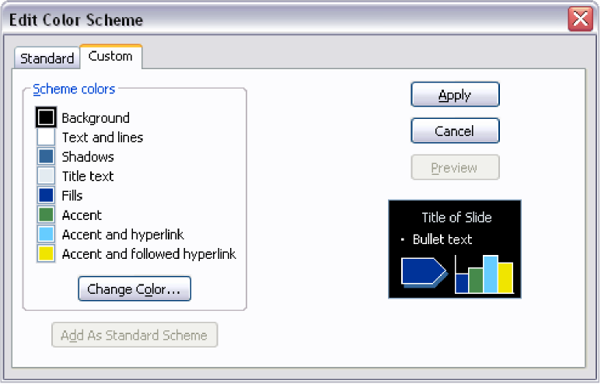

The other section of the “Slide Design” menu is the “Animation Schemes” menu. We will discuss this menu later on in our section about slide transitions and animations. Now, let’s learn how to insert objects and text into our newly designed slides.

1. Inserting Objects:

In your slide, you may wish to insert objects that may not already exist. You will have to insert objects from scratch if you are making your slideshow from a blank presentation, or if you have used a pre-made layout and want to add in more objects. To add in a text box, an image, or some other element, then you have to use the "Insert" menu on the menu bar to perform these functions.

* **Insert New Slide:** Go to the file menu and select Insert >> New Slide. A new slide will be inserted after the slide you are currently working with (shortcut command: Ctrl+M).
* **Insert Text Box:** Go to the file menu and select Insert >> Insert Text Box
* **Insert Picture:** Go to the file menu and select Insert >> Picture and choose from one of the options, depending on what type of picture you want to insert.
* **Clipart:** "Clipart" are images that already come packaged with your computer. These are generally simple images that can be very effective when used in PowerPoint presentation. Clipart also functions as eye-candy for your slideshow to keep things looking interesting. Use the Clipart menus to navigate through different categories of images to find the pictures that best suit your needs.
* **From File:** You can use the "From File" option to browse your computer to insert a specific image that you have saved.
* **AutoShapes:** "AutoShapes" lets you create your own simple graphics, such as lines, word balloons, stars, and other shapes.
* **Insert Slide Number:** In PowerPoint, you can number each of your slides. To do this, insert a new text box for where you want your slide number to be positioned, and select Insert >> Slide Number from the menu bar.
* **Insert Date and Time:** Works just like the above "Insert Slide Number" tool. You must make a separate text box to insert your date and time. Then, select Insert >> Date and Time from the menu bar. A pop up window will then appear, allowing you to select an appearance for the date and time.
* **Insert Movie or Sound:** For a media-rich slideshow, you may decide to display some movie or sound files that you can play during your presentation. You must first have the movie or sound file saved on your computer.
* **Insert Chart:** By going to the menu bar and selecting Insert >> Chart, a spreadsheet will pop up into PowerPoint. You can manipulate data in order to create your own charts and graphs.
* Insert Table: Go to the menu bar and select Insert >> Table to insert a number of rows and columns to create a table. When the table is inserted, a new table menu window will pop up with various formatting features. Here, you can add borders, change the border sizes of the table, and manage the cells in the table.
* **Insert Hyperlink:** If you are giving a presentation on a computer that has access to the Internet, then you may find it helpful to have some hyperlinks in your slideshow, so that you can click on a link while you are presenting and then demonstrate a web site. To insert a hyperlink, go to the menu bar and select Insert >> Hyperlink. Then, a new window will appear for specifying the information regarding the hyperlink you want to insert into your document.

1. Inserting a List:

Lists boxes are the same as any other text box. There are many ways you can create lists in text boxes in PowerPoint.

* The first way is to create a new slide and choose a slide from the pre-made layouts. You can recognize a slide with a list object box by the bulleted list.
* Another way to add a list is insert a new text box in a slide. Then, click inside the box. Using the formatting toolbar, click on the Numbering or Bullets button.
* To start making your list, simply click your cursor next to the first bullet and type. To add a new item to the list, just hit the Enter key on your keyboard to begin a new line.

1. Insert Word Art:

Inserting a WordArt element rather than regularly formatting text can give a little extra flair. WordArt is essentially text effects. To bring up the WordArt Gallery, open up the WordArt toolbar by going to the menu bar and selecting View >> Toolbars >> WordArt. A separate toolbar just for making WordArt will now appear.

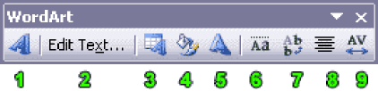

* **Insert WordArt:** When you click on the "Insert WordArt" icon, a WordArt Gallery window will appear offering various styles of WordArt to choose from. Click on a style you like and then press "OK." You will then be taken to the "Edit WordArt Text" window where you can type in the text for your WordArt image.
* **WordArt Edit Text:** You can go back and edit your text for WordArt by clicking on the "Edit Text…" button. In the window that appears, you can format the text by modifying the font, size, bold and italics attributes.
* **WordArt Gallery:** Opens up the WordArt gallery window (see #1).
  + Format WordArt: Formatting your WordArt further allows you to manipulate your WordArt text. You can change the WordArt color(s), alignment and position, lines and borders, and size.
* **WordArt Shape:** You can pick a shape for your WordArt to conform to by selecting a style from the WordArt Shape drop down menu. Some shapes include arches and circles.
* **WordArt Same Letter Heights:** Click on this button to make all of your letters in your WordArt have the same height. The tops of each letter are all lined up across the top equally.
* **WordArt Vertical Text:** Lines up your text vertically so that each letter inthe WordArt is lined up on top of each other, forming a column.
* **WordArt Alignment:** Gives you a selection of text alignments, such ascenter, left, right, and stretched justification.
* **WordArt Character Spacing:** By clicking on this icon, you can choose to have the letters in your WordArt either spread far apart, or packed together tightly.

1. Editing an Inserted Image:

Images that are inserted into a PowerPoint presentation (see above section on "Inserting Objects") can also be modified.

There are a number of things you can do to image object boxes in PowerPoint. If you have a slide using a pre-made layout with a pre-existing image object box, then the first thing you can do is double-click the box to insert a Clipart image. You will then be taken to the Clipart menus, when you can browse through different categories of images. When you find a Clipart you want to insert, a submenu will pop up asking you if you want to insert the image, preview the image, or search for images of similar content. You can choose from any of these options if you want, or you could simply click an image and then click the "OK" button to insert it into the image object box.

Please note that when you change the appearance of an image in PowerPoint, you are not actually changing the original image file, so you don't need to worry about changing a picture in PowerPoint, and then override the image you already have saved.

If you want to insert an image you have on your computer or a disk, and don’t want to insert a Clipart file, then go to the menu bar and select “Insert >> Picture >> From File…”.

Once you have inserted an image, you can change various aspects of that image. For example, using the cursor to click and drag the corners and sides of the image stretches the image out, and increases or decreases the image's size.

Selecting the image brings up a new pop-up menu called "Picture." There you can modify the appearance of your image in a number of ways.

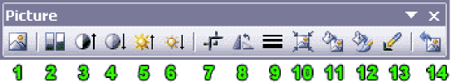

* **Insert Picture from File:** Browses your computer and inserts a saved image.
* **Color:** The drop-down menu here contains functions for changing the look of your image. You can keep the colors of the image the same, make it grayscale, turn it into black and white, or make it a watermark image.
* **More Contrast:** Increases the intensity of color in an image.
* **Less Contrast:** Decreases the intensity of color in an image.
* **More Brightness:** Add white to an image to make it lighter.
* **Less Brightness:** Add black to an image to make it darker.
* **Crop:** Using the Crop tool trims a portion of an image.
* **Rotate Left 90Ń:** Spins the image around in 90 degree intervals.
* **Line Style:** Adds a border around an image. Decide on a line width using thedrop down menu.
* **Compress Picture:** Lowers the visual quality (dpi) of an image. This will make images appear faster in your presentation, but they may not look as nice.
* **Recolor Picture:** Opens up a window that allows you to change colors in your picture. If your image is a bitmap file, then you can only recolor an image if you have an image editing program on your computer, such as Adobe Photoshop.
* **Format Picture:** Clicking this button brings up a more complex and detailed menu for editing your image. Contains options that would not normally be available using the main "Picture" toolbar.
* **Set Transparent Color:** When you make a color of an image transparent, you make it appear to be "invisible" in a picture. Use this tool to click on a color in an image that you want to make transparent. The color will then become somewhat "see-through."
* **Reset Picture:** By clicking on the "Reset Picture" button, you can remove all of the formatting you added to your picture and revert the image back to its original state.

1. Set Up Presentation:

When you have finished your slide show presentation, you can do a bit of prep-work before you view your presentation. Go to the menu bar and select Slide Show >> Set Up Show… The Following window will appear:

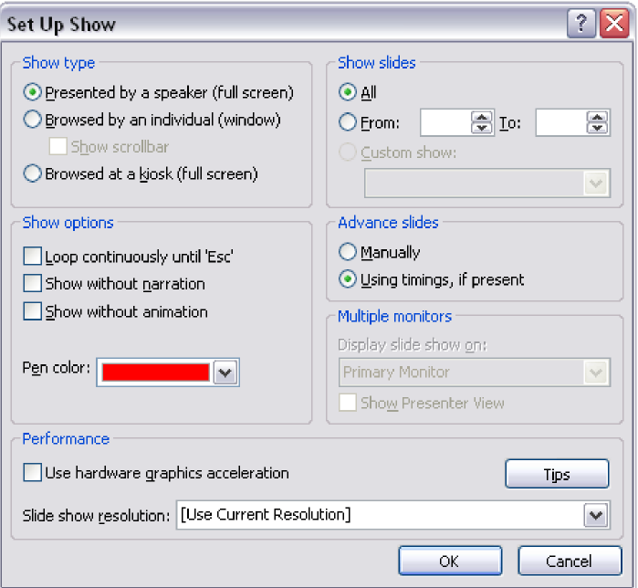

Here, you can specify various options for how your presentation will by. You can set the “Show type” (who is your audience?), which slides to show, if you want your show to loop or play once, how to advance your slides, and set the slide show resolution.

Once you have set up something you are happy with, you can view your slide show presentation.

1. View Your PowerPoint Presentation:

You can view your slide show presentation in a number of ways: you can press F5 on the keyboard, navigate to the menu bar and select Slide Show >> View Show. Once your slide show presentation begins to play, you can transition from slide to slide (and animation to animation) by using one of the following methods: click on the spacebar on your keyboard or use the arrows to go forward and backward through the slides. To end your slide show in the middle of the presentation, press the Esc key on your keyboard.

1. Printing Your PowerPoint Presentation:

If you would like to print out the slides of your presentation, the best way to do so is to fit as many slides on one page as you can (this helps saves paper).

Go to the menu bar and select File >> Print.

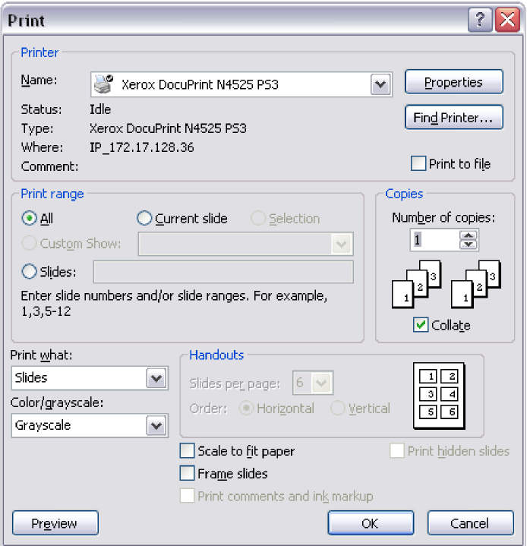

In the Print window, go to the menu near the bottom of the window called "Print what," and select Handouts. Then, in the Handouts pane (which can be found directly next to the "Print What" menu), select how many slides you want to be printed on one page.

To print out slides on their own individual pages, go to the menu bar and select File >> Print. There, you can choose to print just the current slide, a few select slides, or the entire presentation. You should check the box that says "Scale to fit paper," to make sure that the slide fits on the paper.

1. Saving Your PowerPoint Presentation for the Web:

A great way to utilize PowerPoint Presentations for other people to view is to save them for the web and upload them to the Internet. To save your slideshow presentation for the web, go to the menu bar and select File >>Save As Web Page.

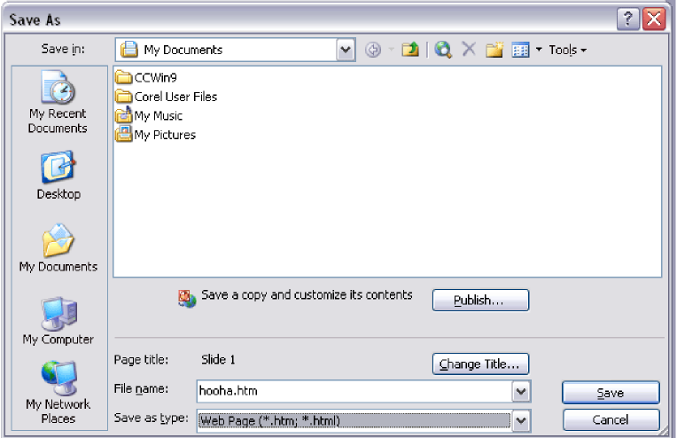

In the dialogue box that appears, give your slide show a name (save the file with the extension ".html"). PowerPoint will save your slide show as an HTML document, with all of your slides as individual files saved in a folder (PowerPoint creates the folder automatically).

To view your PowerPoint as a web page, use Windows Explorer to browse to the saved PowerPoint .html document saved on your computer, and open it in Windows Explorer. A web browser will open up with your slide show as a web page displayed.

The actual slides will appear in the right frame of the screen. You can navigate from slide to slide using the links listed in the left frame of the screen.

**Lab Task**

1. Make a presentation on any topic in groups of four and present that in next lab. Your presentation should include following points

* When and How starts
* History of Topic (Start to 2022)
* Current situation
* Future prospective

***Note: Upload ppt file by one of group member***

**Conclusion**

**________________________________________________________________________________________________________________________________________________________________________________________________________________________________________________________**